“Oppositional Joy”
Listen to the Zoom recording of Sito’s teaching.
December 12, 2021
Texts:
Luke 3:7-18
Zephaniah 3:14-20

There is a tension of the Christian life that has baffled me for a long time. To what extent does our gaze need to be fixed towards evil, and to what extent does our gaze need to be fixed towards goodness or joy?

When I signed up to preach on this Sunday, I did not anticipate such a confrontative gospel passage. It is the third Sunday in Advent, the Sunday we typically dedicate to joy, and yet today, we hear a story in which John the Baptist is furious. Luke takes us directly from the story of John’s birth and pushes the narrative straight into this clash between John the Baptist and the authorities. The throngs of people come to John to be baptized and in response, John says, “You brood of vipers! Who warned you to flee from the coming wrath? Produce fruit in keeping with repentance… The ax is already at the root of the trees, and every tree that does not produce good fruit will be cut down and thrown into the fire.”

On the surface of things, coming to the water to be baptized seems like a pretty harmless ritual. In the Lutheran tradition I grew up in, baptism is one of only two rituals that we claimed as sacrament.
Nonetheless, John the Baptist is dissatisfied with the incongruence of the crowd’s ritualistic expression of devotion. He would rather see lives of integrity, and at the heart of his fury is the awareness that this ritual is not paired with equity. God’s people are using the ritual in a spirit of fear and shortcutting, hoping to avoid God’s wrath.

John goes on, emphasizing what each must do. The crowd must share. The tax collectors and money handlers need to stop skimming off the extra for personal gain. The soldiers should stop extorting the common citizen. As though he can’t get enough, when John finishes, he immediately goes to King Herod and confronts him, too. Then, he is thrown in jail. In jail, we know how John the Baptist is suddenly and arbitrarily put to death.

What does any of this have to do with Advent? What does any of this have to do with joy?

The more I’ve reflected on John’s anger in the gospel passage, the more I’ve become curious about the relationship between anger and joy. What is the interplay between the two in a Christian community? John the Baptist doesn’t do or say anything particularly joyful in all of the Gospels, so does he fall short in preparing the way for Christ?

Zephaniah

Perhaps the starkest contrast comes in our reading of Zephaniah 3. On a recent trip to Saint Louis, I found my grandfather’s ordination bible. I read the Zephaniah passage, and in the margins, my grandfather, who was a pastor, wrote “3rd Advent C,” referring to our lectionary scriptures for today.

Out of curiosity, in addition to the six joyful verses that we heard today, I also read the first three chapters of Zephaniah (none of which had anything in the margins). Indeed, the rest of Zephaniah mostly does not appear in the lectionary cycles. I generally appreciate the lectionary scriptures, but to separate the end of Zephaniah 3 with what precedes it is really a problematic reading.

God speaks through the prophet Zephaniah and the first verse of the book reads as follows— “I will utterly sweep away everything from the face of the earth…” The prophet continues, “On that day, a cry will be heard from the Fish Gate, a wail from the Second Quarter, a loud crash from the hills...I will punish those who are thickening upon their lees, those who say in their hearts, ‘Yahweh will not do good, nor will he do ill.’” (Zeph 1:2, 1:10, 1:12)

To thicken upon one’s lees is a Hebrew idiom that basically means to rest on one’s laurels. So, when Zephaniah characterizes the Israelites as ‘thickening upon their lees,’ he’s basically saying that they are unbothered or unconcerned by God. Similar to the crowd in today’s Gospel, the Israelites are numb to the incongruency of their lives.

They say in their hearts, “Yahweh will not do good, nor will he do ill.” In other words, Yahweh is powerless. Yahweh is incapable of song or fight, joy or anger, affection or resistance. It doesn’t matter what we do. God will not be roused.

But God’s thirst for righteousness and love runs deep. Indeed, the whole book of Zephaniah is an expression of longing. God warns Jerusalem in Zephaniah 3:1, “Woe to the city of oppressors, rebellious and defiled!” Over and over, God demands change, but the Jerusalem will not. So, in verse 8, God responds by saying:

“I have decided to assemble the nations,
to gather the kingdoms
and to pour out my wrath on them—
all my fierce anger. (Zeph 3:8)

God is an active participant in the disintegration of Israel, and Yahweh only allows a remnant to survive. The part that survives is the humble and the meek. The part willing to repent and change. It is precisely in the ruins of this moment — after institutional crumbling and communal humbling — in which God finds a people who are open and finally ready for a true joy. It is in this moment that God’s fury turns into music. The prophet writes:

Yahweh, your God, is with you,
the Mighty Warrior who saves.
He will take great delight in you;
in his love he will no longer rebuke you,
but will rejoice over you with singing.”

Here, the prophetic energy touches the lover energy, and neither is excluded. Neither is sacrificed for the other. God’s “no” meets God’s “yes” and the result is communion between God and God’s people.

Perhaps one element of the Good News of today’s gospel points to a God who wants to integrate all of our humanity. In a strange and vulnerable way, God is saying, I want all of you. Your most raw emotions are not foreign to me.

The Source and Functions of Joy and Anger

What are the functions of joy and anger? When honored and healthy, both are fuel for love. When we listen to joy, we cultivate affection for each other. When we listen to anger, we become aware and willing to challenge the forces that cause despair. Joy is to affection as anger is to resistance. “Both are what psychologists call approach-oriented emotions. They motivate us towards something: conflict, in the case of anger, and [restoration], in the case of joy.”

I believe that Holy joy and Holy anger may have a common root. This common root is what Audre Lorde calls the erotic. She writes:

The erotic is a measure between our sense of self and the chaos of our strongest feelings, for the erotic is not a question only of what we do; it is a question of how acutely and fully we can feel in the doing…it is the nursemaid and nurturer of all our deepest knowledge.”

The deregulating nature of deep feelings can lead us to distrust and fear these high-arousal emotions. In his first letter to the Thessalonians, Paul writes, do not quench the Spirit! But in my experience, the lifeforce of the Spirit is so powerful that I have often struggled to choose not to numb that depth and intensity rather than hold and honor its transformative power.

As I was sharing with Crisely the theme for today’s teaching, she reminded of me of just how much I had suppressed my anger when I had arrived in DC. I forgot this anecdote until she mentioned it to me, but just a few months into our relationship in 2014, I told Crisely “I don’t really get angry.” Of course, that was not true. It was simply a reflection of how disconnected I was from what it meant to value life and protect boundaries.

In the cultural ecosystem of the Lutheran tradition that I grew up in, anger was basically synonymous with sin. Moving into places of raw emotion — like L’Arche, like a middle-school classroom — forced me to encounter my anger, oftentimes through the anger of others. Instead of listening to the anger I felt, I often numbed or denied it. Then, resentment would build. Boundaries would be crossed without accountability, and in the denial of my own anger, I experienced a shame around my own seeming incapacity to say no and to hold the boundary. Then, it would come out sideways towards Crisely, or people in L’Arche, or my middle-schoolers.

Dr Willie James Jennings, a black, liberation theologian, and the former dean of Yale Divinity School, says that discipleship is

the formation of erotic souls, always enabling and facilitating the gathering, the longing, the reaching and the touching…cultivated in an art that joins to the bone and that announces a contrast life aimed at communion. (2x)

Sounds beautiful, yeah?

Unfortunately, according to Dr Jennings, the vast majority of Western Education has a Eurocentric vision of maturity that moves us towards the opposite of eros. In most seminaries and universities, he sees people being formed towards three qualities: 1) possession, 2) mastery, and 3) control. And though we long for intimacy and belonging, he sees our clergy being taught to settle for an armored self-sufficiency.

So how do we break free from self-sufficiency? How do we live in the pathos of God and allow ourselves to be unraveled so that we can inhabit joy and anger in life-giving ways?

Justicia

For the rest of the teaching, I’d like to move through two pieces of art that are helping me feel my way into anger and joy. The first piece of art is a song from a Bronx-born, Puerto Rican pianist and salsa arranger named Eduardo “Eddie” Palmieri. Palmieri was part of the avant-garde of the salsa movement in the 60s and 70s, at a volatile time when the Nuyoricans (the Puerto Rican community in New York) were discovering their power following the groundwork of the Civil Rights Movement.

In 1969, Palmieri arranged an album called Justicia. I’m going to share about two minutes from the middle of the title song. The lyrics are a prophecy of justice — specifically for the black community and the Puerto-Rican community.

In most Nuyorican salsa from this era, there is usually a part of the song called the montuno. Typically, two things happen in a montuno. First, there is usually a call and response between the back-up vocalists and the main vocalist. In this song, the backup singers sing — When will justice arrive? ¿ay, cuándo llegará la justicia? Between this repeated choral line, the main singer improvises and responds to the back-up vocals.

In addition to a vocal call-and-response, the second thing that happens in the montuno is an instrumental call-and-response. This is the part that I am most eager to share with you today. As you listen to the montuno in this song, which will begin about 15 seconds after I press play, I want to invite you to look away from the screen or close your eyes so you can really hear the musicality. As this song transitions into the montuno, you will hear four instruments — the piano, the conga, the bongo, or the cowbell. As you listen, I want you to focus your attention on the sound of any of those instruments and see if God stirs up anything in you.

[Play “Justicia” by Eddie Palmieri. (1:15-3:30)] You can listen to this part of the teaching by going to the Zoom recording of Sito’s teaching at 15th min, 47th second (15:47).

To me, this song sounds like today’s scriptures. There is a gritty, oppositional joy. There is a humanizing joy from those who’ve been given dehumanizing conditions. Justicia is John the Baptist, set to music. I stopped the song early, but in the following two minutes, the song hits a frenetic crest; on top of the bongo, the conga, the piano, and the cowbell, the montuno then adds a horn section. The bitter trombones and the outcry of the trumpets are the final layer of sound. All of it is a response to the systemic forces that crushed poor peoples of color in New York City. All of it, rooted in the pride and joy of being Latino.

Richard Rohr says that whatever pain we don’t transform, it will surely be transmitted. The hard, brash, socio-political salsa of Eddie Palmieri was an expression of pain transformed. In that community, in that epoch, in that music, we find a people that turned a forced segregated into joy. We hear the cross-pollination of Black and Latinx musical traditions — strains of jazz and blues — folded into a driving rhythm that opens up in the montuno.

We are a community that knows the fruits of silence, but to what degree are we a community that knows the ecstasy of sound? To what degree do we inhabit a joy set to the music of resistance? What would it look like to join hands with communities that practice an oppositional joy?

The Way to the Promised Land
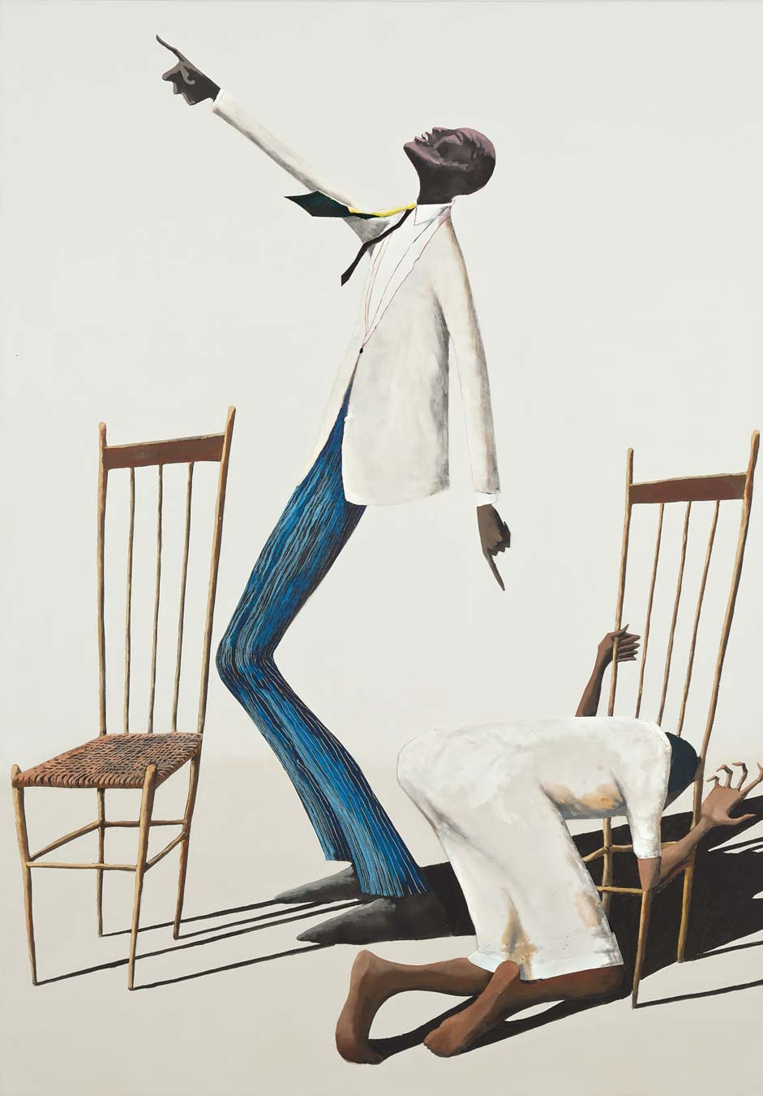
The next piece of art that I want to share is a painting by Benny Andrews, a self-described “People’s Painter” who was born in rural Georgia in 1930, the son of sharecroppers. The painting is a profound portrait that links joy and anger, good and evil. In this portrait, you notice that the man who is standing is pointing his fingers in two directions — one finger is towards his neighbor in pain. This person, as though taken straight from Psalm 23, is in the valley of the shadows. They are physically in a low place in the portrait, and you can see the shadows consuming them. The hand that grips the chair seems to grip a bar — a set of bars one might find in a prison.

On the other hand, the standing man is pointing to the horizon. The horizon is breathtaking. It is knee-buckling. It is so good that he has to lean back to take it in.

I love this painting because it shatters the false dichotomy of anger and joy in the Christian life. We don’t have to flatten our joy by separating the end of Zephaniah 3 from its context. We can face the prophetic energy that calls us in to the searing pain of the world. And similarly, God invites us into the work of joy with the posture and mood and gaze of the standing man, contemplating what will and what could be.

Andrews entitled this painting, “The Way to the Promised Land.” As we move towards the fourth Sunday in Advent, Benny Andrews points us in two directions, but both lead to the Promised Land.

More and more, I’m convinced I cannot get to the promised land alone. The unquenchable Spirit inhabits each person in totally unique ways. Some of us enter the energy of joy and praise naturally. Others of us have followed and honored the wisdom of anger more faithfully. Some of us might find both of these high-arousal emotions really difficult to access. Others of us might feel like we’re always vacillating between the two. Others in our community remind us that we don’t have to permanently live life at a high volume.

One of the gifts of being married to Crisely is that she is often, in the language of her own being, showing me how to find a quiet and steady center from which I can listen to others. As we create a culture that allows for God’s passion, we all lead and we all lean on one another to make it where we could not go alone.

Inherent to a contrast life aimed at communion is an encounter, a gathering, and a process of learning to pay attention and hold the fullness of each other.

Fundamentally, this joy work lives in our bodies. We feed each other, not in the abstract, but with the energy that we bring and hold in our physical selves, even on Zoom. In the way we nod and smile and laugh. In the ways we lean in or hold back. In the felt intimacy of gathering in person.

Joy work is also body work within the body of Jesus. We come to communion and we hear Jimmy Speer saying, the Bread of the Lord. I can envision the way Marja will look into my eyes. I can hear Crisely saying, Alfonso, el cuerpo de Cristo. I can remember the way Richard and Fred would practically leap from their seats in the front row to be first in line with the musicians.

The forces of socialization are usually moving us towards self-sufficiency. The gospel, however, is always pointing us towards a healthy interdependency, which is impossible without Holy Joy and Holy Anger.

Here’s an untitled poem from Dr Jennings.

Could self-sufficiency
be redeemed?
But who would want
such a thing?
Certainly not one who asked
Mary for life, or one
who needed friends along
the way of discipleship, or
one who called on an Abba-God, or
one who fell onto God’s Spirit
like a limp body
in need of support just to
face the morning sun
or one who said, “This is my body and my blood,
eat me
because you need me in you.”
Certainly not one who on a cross
killed the illusion of
self-sufficiency.

This Advent, we revel in the coming of Jesus. God’s eros means that God wants to be with us. To challenge us. To laugh with us. To eat with us. To relish a life together. God, grant us wisdom and humility and courage to embrace our need for one another. We want to welcome the fullness of each other. We want to be a home for You. Amen.

Sources:
The Uses of the Erotic — by Audre Lorde
“Justicia” — by Eddie Palmieri
“Joy is Resistance Against Despair” — Dr Willie James Jennings
“Gathering Joy” — by Dr Willie James Jennings
After Whiteness: An Education in Belonging — by Dr Willie James Jennings
The Way to the Promised Land — Benny Andrews

