Today I want to wrestle with 3 biblical concepts that I have felt are often confusing.

The concept of being “Born Again”

The Crucifixion and the cross. I found myself hesitating to put a cross on a Lenten quilt a few weeks ago, asking myself, what is the cross’s significance?

Eternal Life and the Kingdom of Heaven or the Heavenly world of God
John 3:1-21 has all of these main themes and they have shown themselves to me as interconnected.
“Born Again” is a cultural phenomenon where I am from, Memphis, TN. At least in the white churches I occasioned, once you believed through some change of your thought or belief, in that moment you were part of a community, you were given belonging, even privilege or access you had not had before. The result was effectively that you label yourself as a born-again Christian and claim membership to a church home whether you go or not. It is Southern conformity and access to belonging that does not necessitate Christian growth beyond your first conversion story. Black churches in Memphis may have some of the same phenomenon, but the facts are that Memphis is one of the cities in the poorest and blackest five states in our nation where I imagine that black churches are more about being places of safety and solidarity and communal resources in the face of active inequity regarding real life access to money, land, and physical safety.
Nicodemus was a leader in a congregation like a white church in Memphis and would have LOVED this concept of born again, at least the way it led to control of congregants.
“Very truly I tell you, no one can see the kingdom of God unless they are born again,” Nicodemus spoke Chaldean Aramaic and Jesus said the phrase “born again” in Galilean Aramaic so Nicodemus is confused and takes it literally, challenged beyond his understanding. That was what Jesus wanted – for Nicodemus to be confused and challenged
In the chapter before, Jesus just blew up at the temple yelling that he would destroy it and rebuild it in three days and now Nicodemus, an elder religious Jewish leader, comes in the middle of the night. Maybe because he is curious to know the source of Jesus’s authority?
Maybe because he truly is in awe and suspects Jesus may be from God?
Maybe to quell Jesus’s passionate beliefs as Jesus overthrew the moneychangers in the temple just before this visit.
Jesus wants Nicodemus to understand that knowing the Dominion of Heaven is as difficult as crawling into the womb to be born again. In Jesus’s Galilean Aramaic, one meaning is to see like a child and understand like a child. (Remember, for the Kingdom of God belongs to such as these.) Nicodemus is an old man with religious authority. Of course he would be confused, possibly dismayed, possibly angry or insulted.
WE should be confused and challenged by this statement. We should see this as difficult.
“Very truly I tell you, no one can see the kingdom of God unless they are born again”
Being born again is NOT supposed to be easy, quick or comprehensible.
It is not easy – Being born again is not the one conversion moment, it is not only cognitive thought, or only emotion or feeling, it is a whole body and mind experience. It is a rebirth that implies some kind of death
It is not quick – I could point to multiple moments of rebirth in God after something has ended in my life. My parents’ divorce, my older sisters’ going off to college or getting married, my idea that my children would have taken the advantages I had growing up.
As in Judith Viorst’s book by the same title, we all have Necessary Losses. Throughout our lives, throughout many moments. These are opportunities to be reborn. Many more losses as we grow older.
It is not all that comprehensible. How difficult it is to see ourselves and the world like a child, with innocence and wonder. It requires us to continually put aside so many of our attachments (as the Buddhist would say), many ideas of our own, maybe our own calling for a new calling! I still feel I need parts of me to “die” so that Christ may live within me to live a life loving God’s creation and working toward realizing justice and compassion for all. Even my job/calling has become an attachment where I can do amazing accompaniment with hurting others but attach myself to the salary I am paid and the kudos I get from other staff.
So it is hard, maybe impossible to be fully born again. but do you remember Ben’s question last week? Are we ready? Born ready! We are wired to shed our attachments and nurture the divine spark within us. As babies we had all we needed to become what God intends for us, fully us, like Ben said last week.
Now the crucifixion…verses 14 and 15…
3:14 And just as Moses lifted up the serpent in the wilderness, so must the Son of Man be lifted up, 3:15 that whoever believes in him may have eternal life.
In Numbers, from the OT, the people complain and “the LORD sent poisonous serpents among the people, and they bit the people, so that many Israelites died.” After much pleading by Moses to take the serpents away, the Lord says, "Make a poisonous serpent, and set it on a pole; and everyone who is bitten shall look at it and live."
God could have sent the serpents away and not let anyone get bit, but God chose for them to instead stick around and continue to attack. God’s solution was to allow suffering and healing to happen together. Suffering breaks our heart, gets our attention, shedding some of our attachments and bringing us back to our essence. What is more is that God uses the very thing that is killing them to be lifted up and looked upon to heal them.
There is an invitation here to pay more attention to the pain we carry inside, old grief, new resentments, fears we may deny ourselves on a daily basis to function. When we hold our own suffering with some loving care and allow it to be a fact in our lives, we have more capacity for compassion for the world. This suffering is also a way in which we experience smaller deaths from which we find ourselves reborn.
In John, Jesus recalls the Numbers passage by saying just as the serpent was lifted up, so must the Son of Man will be lifted up and whoever believes in him may have eternal life.
The phrase the “Son of Man” in biblical language is the archetype of man, the essence, the root of human.
Lifting up means the act of elevating someone in position and power.
Lifting up also means crucifixion in Roman times when a man’s arms were tied to a horizontal pole while being lifted up onto a vertical pole and set into place to suffocate the individual. This was a horrible execution for crimes and insurrection that many suffered during the time of the Roman rule. Jesus was among these. He preached like many prophets did at that time in the chaos of Judea. He went into the homes and synagogues of some of the poorest in the country, announcing that God’s kingdom was greater than Rome which excited people. In Jerusalem, he acts on his fury of those defiling the temple and challenges the Jewish leadership in this way.
The Jewish leaders took him to Pontius Pilate who gladly followed through with their wishes and crucified him, making him a martyr with significant fallout. The 300 years that followed demonstrated this nonviolent resistance with 10,000 people opposing the Roman empire in order to have freedom – for life, for worship. This did not stop until Constantine becomes Christian in 300 AD. Now instead of Christians taking a vow not to be soldiers and not to kill, Constantine required all Christians to be soldiers and provided Roman buildings for churches instead of people meeting in houses thus Constantine is co-opting the potency of Christianity and making to be “born again” to be easy, quick, and comprehensible. We are not all called to become martyrs, but in the midst of entrusting our life to Jesus, we live without fear of death on all levels. Richard Rohr says, “I would ask you to consider the crucifix as a homeopathic image, like those medicines that give you just enough of the disease so you could develop a resistance and be healed from it. The cross dramatically reveals the problem of ignorant killing, to inoculate us against doing the same thing.” This healing is not just each one of us but healing of our culture. Who is crucified today on the cross? What pain do we continue to as a society continue to inflict and how do we individually and collectively maintain the fear and the greed that feeds that violence. So born again involves both waking up and then dying.
Now on to Eternal Life……
3:16 "For God so loved the world that he gave his only Son, so that everyone who believes in him may not perish but may have eternal life.
3:17 "Indeed, God did not send the Son into the world to condemn the world, but in order that the world might be saved through him.
Believing in Jesus means not the cognitive rumination we may give it but the meaning of the biblical word for believing in Jesus here is that we would entrust ourselves to God, to place ourselves in the hands of God in confidence and trust. And that means WE would both be willing to be lifted up and be willing with joy to suffer oppression and even death without fear knowing it would mean justice and freedom for others.
For those who did not want to die but did for their calling – Martin Luther King Jr. “Presente!” Oscar Romero “Presente!” Rachel Corrie “Presente!”
They were already living their eternal life, already seeing the Heavenly World of God with eternal eyes.
Eternal life here does not mean mere endless duration of human existence but is a way of describing life as lived in the unending presence of God, to live a changed life right now, no longer defined by the fear of death but living a life in touch with God’s will for the world. God loves the world! God gave Jesus to the world. And whoever entrusts their life to God’s ways will be living in God’s reality right now. For all those who have lived this way and brought God’s Dominion on earth but died a natural death. – Gordon Cosby, “Presente”; Harriet Tubman, “Presente”; John Lewis, “Presente”.
How do we know we are living in this reality? How do we know we are in the midst of actually being in heaven here now? How are we creating the Dominion of God now while on earth? Jesus goes on to say in verse 18
3:18 Those who believe in him are not condemned; but those who do not believe are condemned already, because they have not believed in the name of the only Son of God.
In the Message: John 3:19-21 “This is the crisis we’re in: God-light streamed into the world, but men and women everywhere ran for the darkness. They went for the darkness because they were not really interested in pleasing God. Everyone who makes a practice of doing evil, addicted to denial and illusion, hates God-light and won’t come near it, fearing a painful exposure. But anyone working and living in truth and reality welcomes God-light so the work can be seen for the God-work it is.”
Living in Truth in Aramaic is living in genuineness, authenticity, and sincerity.
CS Lewis wrote a book called The Great Divorce where he describes hell, the people in Hell, and the bus stop that takes them to heaven for a second, third, fourth chance up to eternity chance to stay. Lewis begins with his description of a town, Hell, permanently in twilight and always raining with no one living there. The only people about was the crowd of people in line to get on the bus to go to heaven. From Chapter 1….
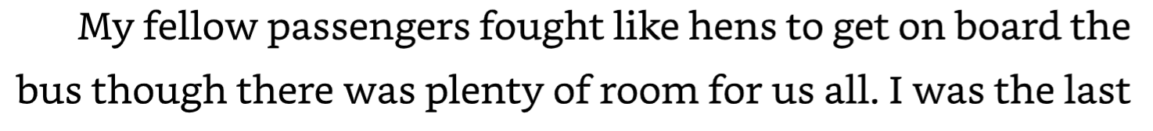
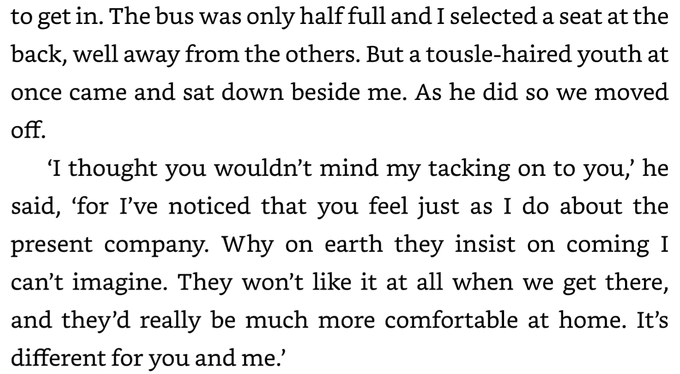
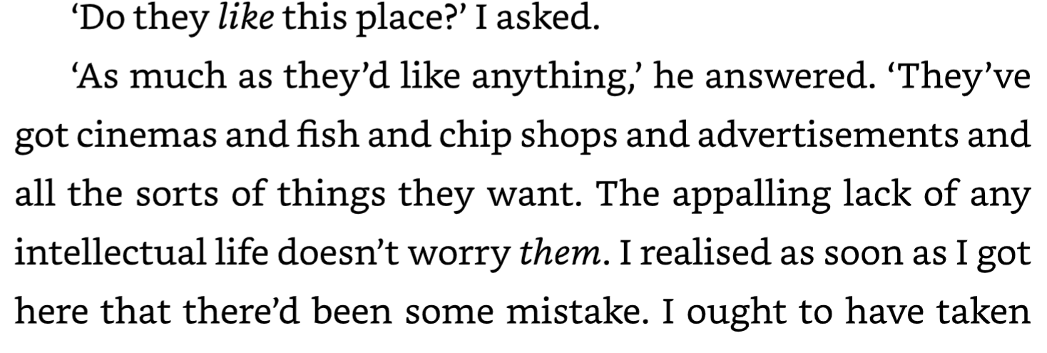
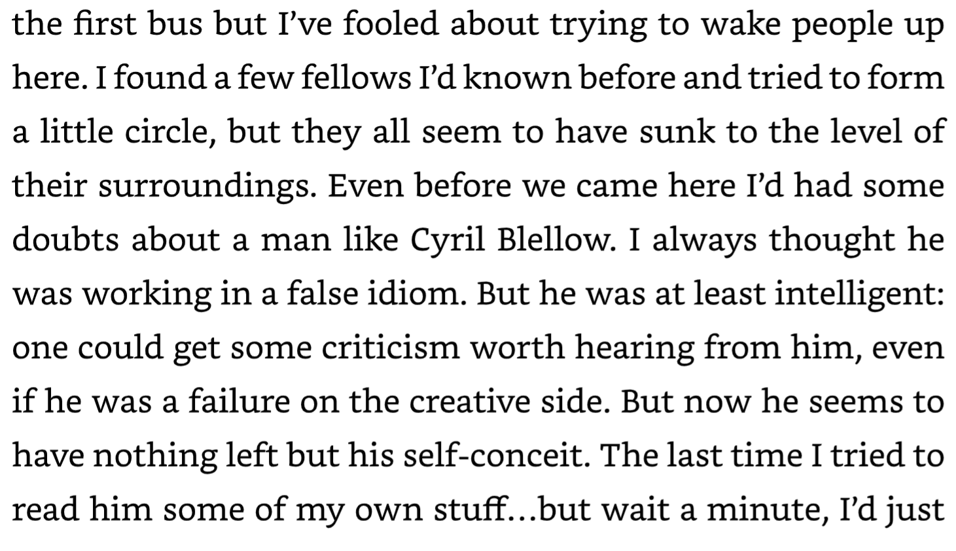
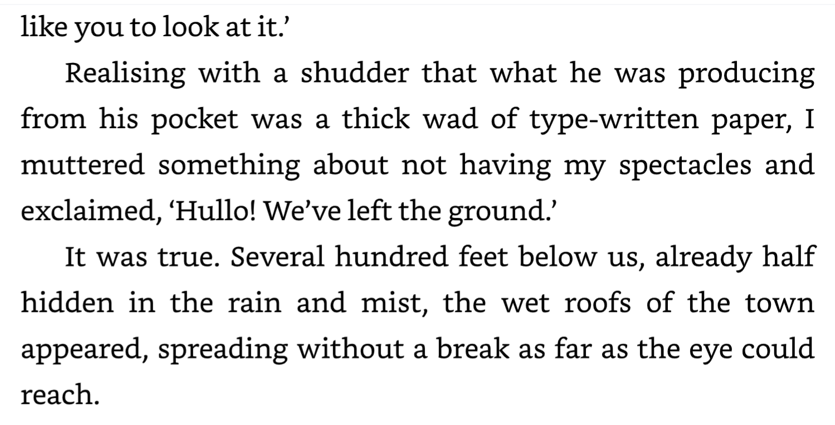
From Chapter 2:
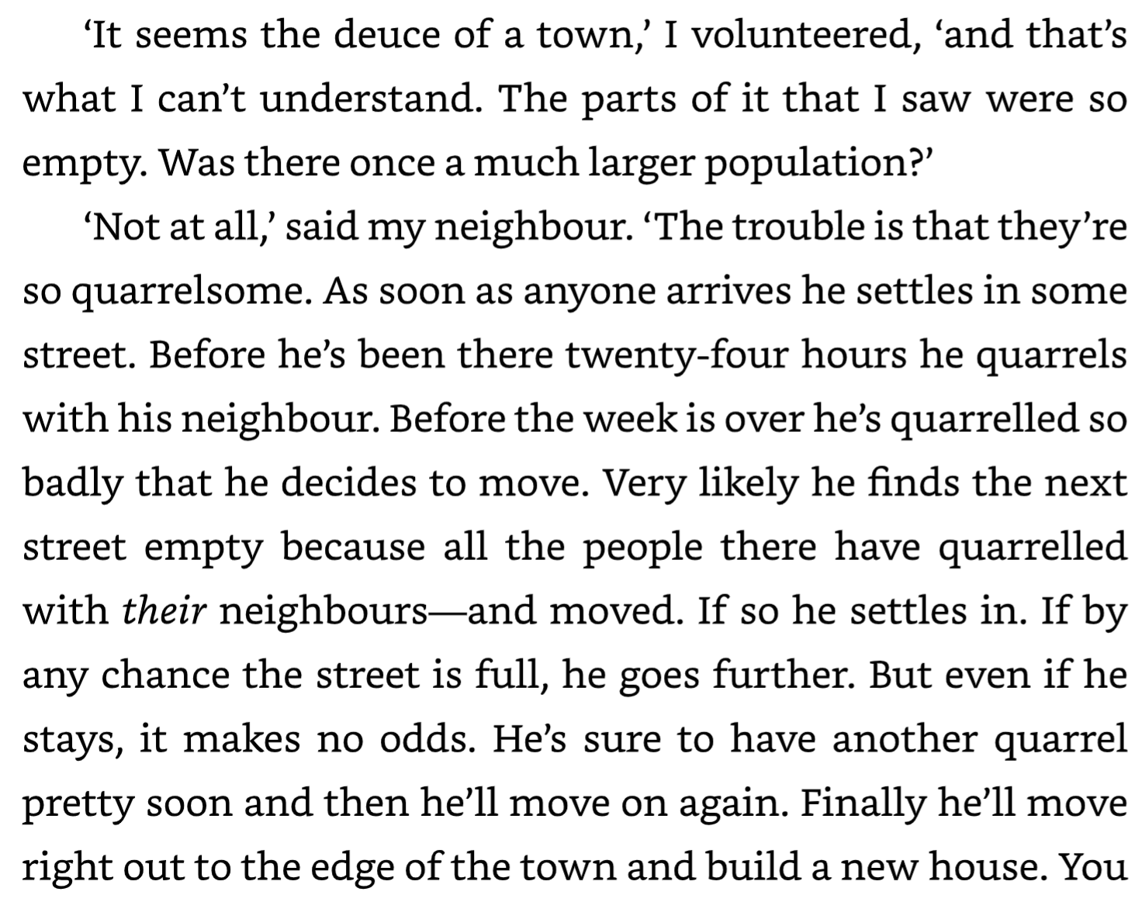
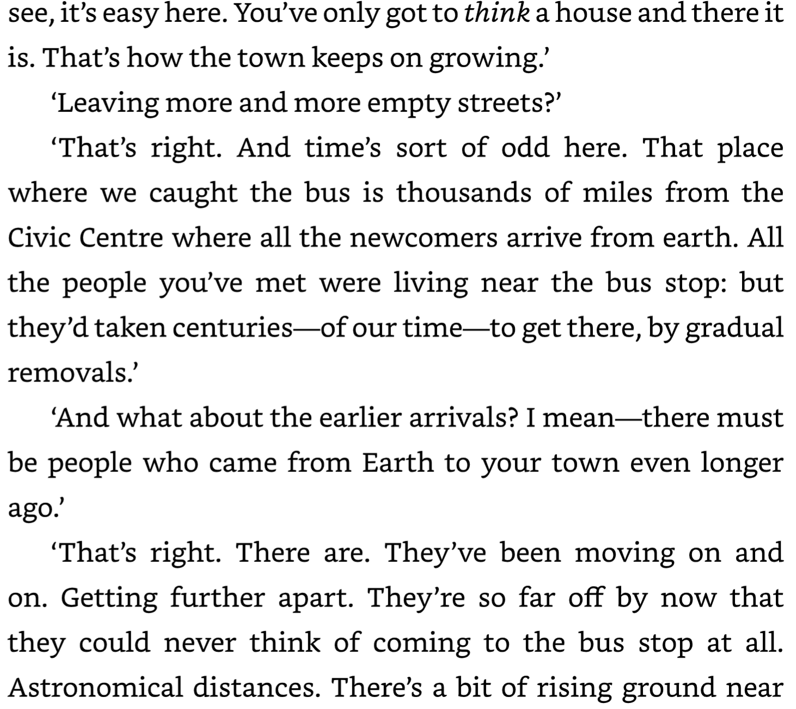
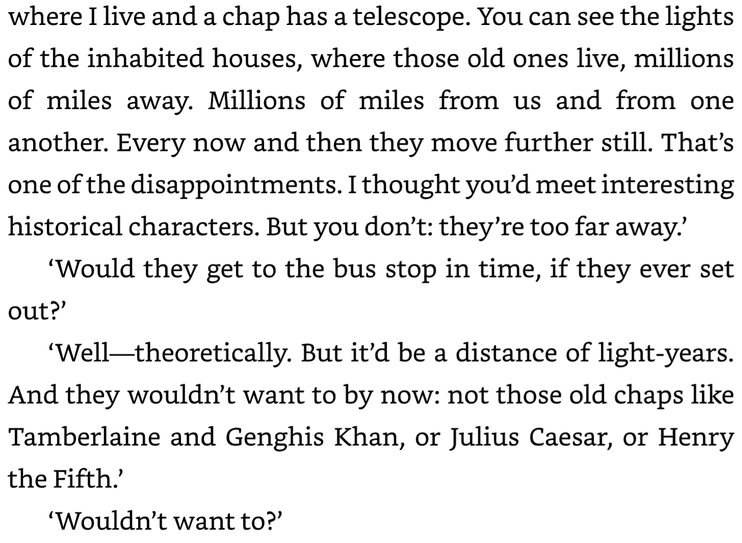
Later on, the passengers arrive in Heaven….
In heaven, he tells of one story where a man from the bus encounters the murderer in Heaven of his friend Jack. The murderer has surrendered himself to the light, had been forgiven and had forgiven himself. He is in heaven and pleads with the man to let go of his thoughts of this event. And invites him to start anew with joy to the mountains. The man protests saying he just wanted his rights, that he was a good man and deserved the justice he thought needed to happen. Ultimately he refuses, unable to let go of this past resentment and would rather keep resenting in hell than surrender those thoughts and enjoy heaven.
What are the ways I hold onto darkness or have been seduced by darkness in my life that make it difficult to choose light? What is the darkness I partake in daily?
How much do I need to face the darkness within me and around me to be able to leave it behind, allowing it to die?
What is the light I miss when I choose that darkness? What light am I missing?
How does choosing the light bring me joy?
How can I see and experience the world with God’s loving forgiveness and the Spirit’s genuine curiosity to find the Divine Spark in others?
How does extreme grief transform us and have us born again? ….
Here is a family story….
My cousin Martha lived in Seattle and was never a born-again Christian but shed much of her life for a new life and practiced Buddhism in a formal way in the last ten years of her life.
Gladys is an African-American woman who rented a small substandard house on the edge of our grandfather’s farm on Horseshoe Lake in Arkansas.
Our cousin Lee Baker lived on the land as well with his wife and three young sons.
Next door, Martha’s mother lived, my Aunt Sally.
In September of 1996, Travis, Gladys’s 16-year-old grandson who did odd jobs for Sally, came over to Aunt Sally’s house with an older gang member to rob her. They found her home and knocked her unconscious. Lee, next door, interrupted the robbery by coming in the back door. They shot him dead and decided to burn the house; then they left in Aunt Sally’s car. Aunt Sally died of asphyxiation. Travis alone was arrested and half of my family wanted him to get the death penalty. I responded in the desert of Danville by speaking out against the death penalty as a family of a murder victim. Mainly because I had heard Conrad’s sermon on Virginia’s death penalty month’s before and thought my voice was needed. Conrad had named Danville as the place where Bill Fuller had sentenced 10% of the people on death row at the time. I became politically active with my grief.
Martha was living in Seattle at the time and her response was much more emotional and was in extreme grief and confusion. She brought all that with her as she upended her life in Seattle and moved into my grandfather’s house. For the next 20 years, she held her grief and confusion with love, seeking connection with Lee’s children, Lee’s wife Carol, Gladys, and Travis himself. Martha wrote to Travis in jail seeking understanding of the details and of his life. Lee’s three sons grew up and were influenced by Martha’s forgiving and loving spirit: Joe Baker, Lee’s oldest son became sheriff in nearby Hughes Arkansas and Lee’s youngest, Ben Baker, a public defense lawyer in Memphis. Twenty years later, 2016, Martha gave Gladys a ride to Travis’s parole hearing, where Martha testified for the victim’s family with Joe as sheriff backing her up, in support of Travis’s release. Travis was released. Martha supported Travis’s freedom in small ways such as odd jobs around the house and Travis went to live with an uncle in Memphis at some point. This is a picture of life being born again out of death, out of living without fear of death either past death or future death or your own grief and a picture of living in the middle of the Heavenly World of God.
Martha McKay, “Presente!”

